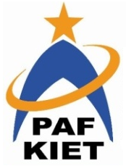
PAF-Karachi Institute of Economics & Technology
(The Center of Excellence)
College of Computing and Information Sciences
Course Project Proposal Form

Sno. | Stud. ID | Names | Course Name/CID
01 | 12436 | Hur Raza | 105726
02 | 12408 | Muhammad Meesum | 105726

Project Title: ROBOTICS
_____________________________________________

- Motivation:
Robotics technology influences every aspect of work and home. Robotics has the potential to positively transform lives and work practices, raise efficiency and safety levels and provide enhanced levels of service.
Robotics involves design, construction, operation, and use of robots. The goal of robotics is to design intelligent machines that can help and assist humans in their day-to-day lives and keep everyone safe.

- Functional Features:
The website will have five main landing pages:

- Home
In which we define what is robotics and
- Blog
Articles about unique robots and upcoming news.
- Project
Project which we and are team made.
- Services
Services which we provide to our clients..
- About / Contact
Information about us.

- Project Planning:
According to our planning , I Hur raza will design and develop three pages includes Home, Services, About and My other group member M. meesum will develop the other two pages which includes Blog and Project. However we shared the work but we will help each other which will make our team more confident. And Inshallah we will complete our project till 15th to 21 November.

Student’s Signature: Hur Raza / M.Meesum
Date: November 6th, 2020

